Experiment 9

Aim: Determine the geolocation (country, city, or approximate location) of each IP address (atleast 10) One can use online IP geolocation tools, databases, and various techniques to gather information and accurately identify the physical location associated with each IP

Theory:
An IP (Internet Protocol) address serves as a crucial identifier for devices within a computer network utilizing the Internet Protocol for communication. These addresses play dual roles: first, they facilitate host or network interface identification, allowing devices to communicate within a network; second, they provide location addressing, enabling the routing of data packets across the vast expanse of the internet.There exist two primary types of IP addresses:

- IPv4 (Internet Protocol version 4): This version represents the most prevalent iteration of the IP protocol. IPv4 addresses are constructed as 32-bit numerical labels, typically expressed in a format comprising four octets separated by dots (e.g., 192.168.1.1).
- IPv6 (Internet Protocol version 6): IPv6 stands as the latest iteration of the IP protocol, developed to counteract the looming exhaustion of IPv4 addresses. IPv6 employs a 128-bit address scheme, typically presented in hexadecimal format and demarcated by colons (e.g., 2001:0db8:85a3:0000:0000:8a2e:0370:7334).

Physical Geolocation from IP Address:
Although IP addresses themselves do not inherently convey information regarding physical locations, several methodologies and services are employed to map IP addresses to geographic coordinates. This process, commonly referred to as IP geolocation, encompasses the following key methods:

- Geographic Information System (GIS) Databases: These repositories house comprehensive datasets correlating IP address ranges with corresponding geographic locations. Compiled from diverse sources, including Internet Service Providers (ISPs), GIS databases furnish approximate geographic coordinates based on registered data.

- Wi-Fi Positioning: In scenarios where the IP address corresponds to a device tethered to a Wi-Fi network, Wi-Fi positioning methodologies come into play. Leveraging the known locations of Wi-Fi access points, this technique estimates the geographic position of the device.

- GPS Data: Certain devices, particularly mobile devices, may transmit GPS coordinates as part of their IP address information. This method yields greater accuracy, especially for mobile devices equipped with integrated GPS capabilities

- Proximity to Network Infrastructure: By discerning the physical location of network infrastructure components such as servers or routers, analysts can approximate the location of an IP address. This approach is particularly relevant for fixed-line connections, where the proximity to network infrastructure aids in location estimation.

In summary, while IP addresses themselves lack intrinsic geographic information, various methodologies, databases, and technologies enable the determination of physical geolocations from these numerical identifiers, facilitating a broad spectrum of applications spanning from cybersecurity to targeted marketing.

Output:

- Google
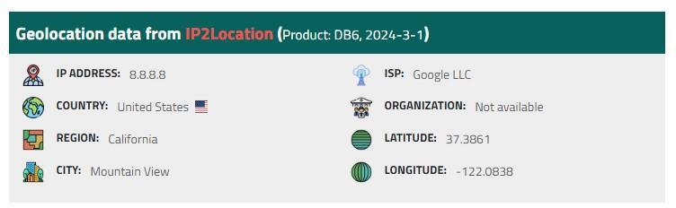

- Linkedin
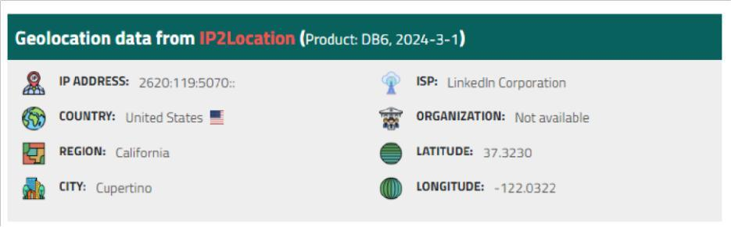

- JPMC
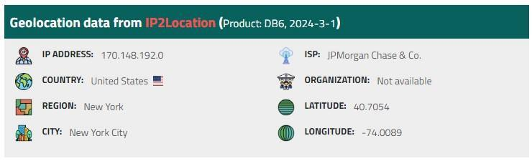

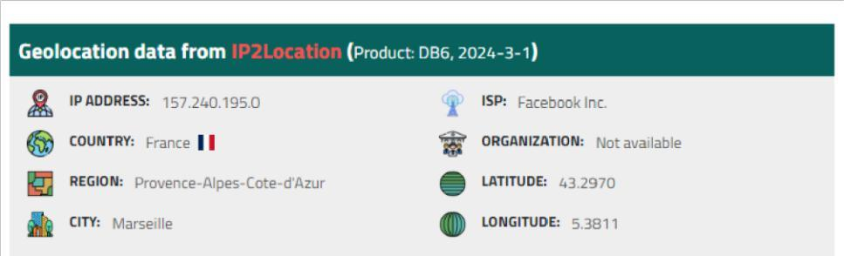
- Facebook :

5. Amazon
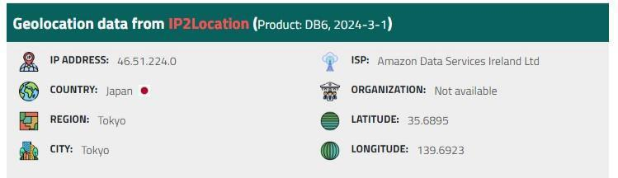

- Lumen Technologies :
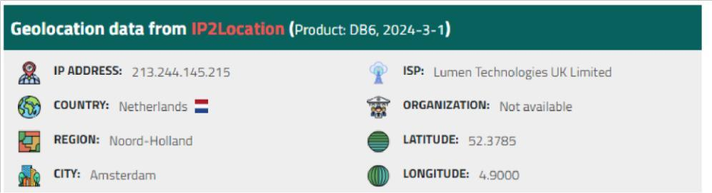

- Samsung :
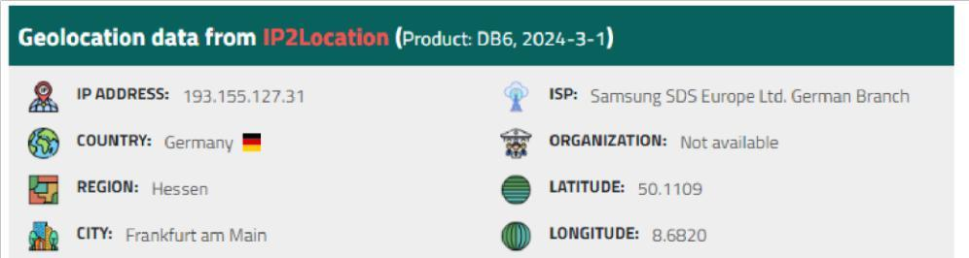

- Twitter :
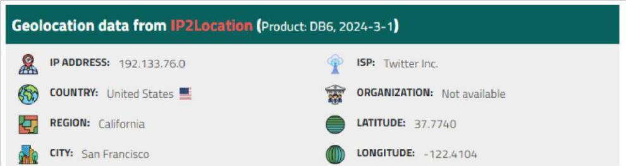

- Walmart
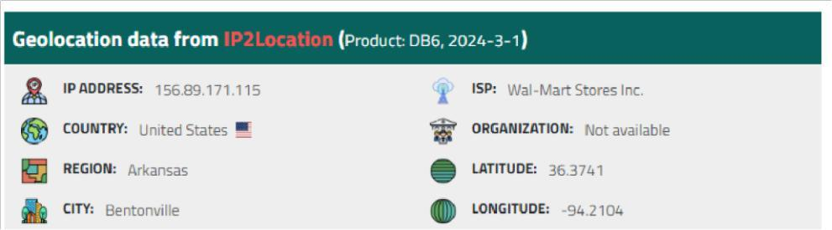

10. Toyota
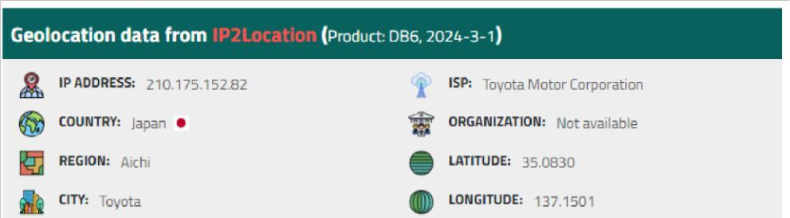

Conclusion: In conclusion, the process of determining the geolocation of IP addresses is crucial for a multitude of applications, ranging from cybersecurity to targeted marketing. Despite IP addresses inherently lacking geographic information, through methodologies like GIS databases, Wi-Fi positioning, GPS data, and proximity analysis to network infrastructure, accurate approximations of physical locations can be achieved. IPv4 and IPv6, representing the two primary versions of the Internet Protocol, serve as the foundation for this geolocation process. By leveraging these techniques and tools, one can effectively map IP addresses to their respective physical locations, enabling informed decision-making and enhancing various aspects of digital operations and security protocols.

